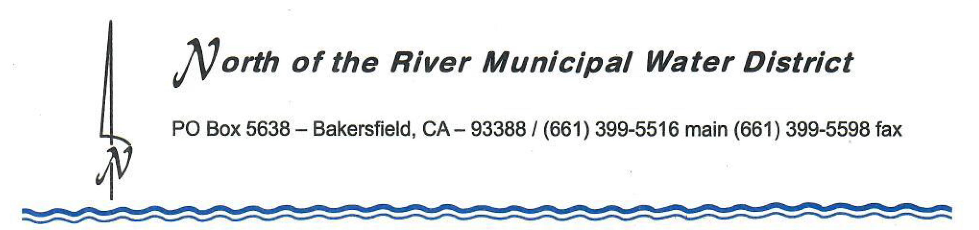

March 1, 2022

NOTICE OF PUBLIC HEARING
TO ALL PERSON INTERESTED IN THE ADJUSTMENT TO DIVISIONS OF NORTH OF THE RIVER MUNICIPAL WATER DISTRICT

The North of the River Municipal Water District (District) is required to review division boundaries after the US Census. All political bodies use the same information from the US Census Bureau. The purpose of the adjustment to divisions is to insure each Division of the District is as nearly equal in population as may be. The District has reviewed several scenarios and has developed a map for accomplishing the update to the existing five divisions of the District pursuant to Cal.Elec.Code § 22000, subdivision (a) Each district required by its authorizing act to adjust division boundaries pursuant to this section shall, by resolution, after each federal decennial census, and using that census as a basis, adjust the boundaries of any divisions so that the divisions are, as far as practicable, equal in population and in compliance with Section 10301 of Title 52 of the United States Code, as amended, to the extent those provisions apply. In adjusting the boundaries of the divisions, the board may give consideration to the following factors: (1) topography, (2) geography, (3) cohesiveness, contiguity, integrity, and compactness of territory, and (4) community of interests of the division. This section does not apply to divisions in which only landowners vote for directors or whose directors are all elected at large or appointed; and subdivision (b) The resolution specified in subdivision (a) shall be adopted by a vote of not less than a majority of the directors.

A public hearing will be held on March 7, 2022 at 4:30 p.m. to discuss the proposed adjustment to the divisions at the District’s Board Room located at 2836 McCray Street, Bakersfield, CA 93308. A copy of the proposed updated divisions is available for viewing at the District Office located at 2836 McCray Street, Bakersfield, CA during normal business hours or on our website at: http://www.normwd.org/. Further inquiries regarding the redistricting process, or requests for further information, may be directed to the General Manager.

